Lab Report 3: Strain Gauge

Lilo Heinrich

**Introduction**

In this lab, I built a circuit that uses the voltage across a strain gauge sensor to measure mass. The circuit uses a Wheatstone bridge to measure the small voltage changes, a potentiometer to calibrate the measurement circuit, and an instrumentation amplifier to increase the resolution of the data.

**Evidence**

Here is the data collected in the lab:

|  |  |  |  |  |  |  |
| --- | --- | --- | --- | --- | --- | --- |
| Mass  Added (g) | 11.1 | 37.8 | 66.0 | 114.4 | 184.6 | 261.1 |
| Voltage Measured (V) | 0.0054 | 0.0105 | 0.0220 | 0.0337 | 0.0541 | 0.0665 |

The calibration curve below was created by finding the best fit line of the data as Voltage vs. mass. Since the mass is linear to the voltage measured by our circuit, the best fit line is shown graphed and below.

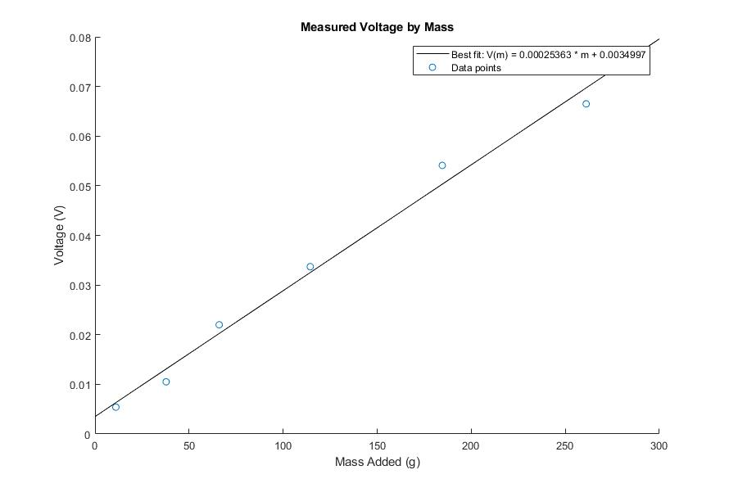

$$V\left(m\right)=0.00025363*m+0.0034997$$

**Analysis and Interpretation**

Rearranging the best fit equation from the previous figure, I can compute the mass of an object using the voltage reading in much the same way that a bathroom scale does:

$$m\left(V\right)=\frac{V-0.0034997}{0.00025363}$$

For example, for a voltage difference reading of 20mV, the corresponding amount mass added to the scale would be 65.1 grams.

Next, to measure the sensitivity of this circuit, I calculated the relationship between change in voltage and the change in electrical resistance of the strain gauge as well as using my best fit line to compute the associated change in mass. My work to derive this equation is shown below.

$V_{out}$ = output of the instrumentation amplifier

$V_{measured}$ = measurement obtained from the analog discovery

ΔV = voltage difference across the Wheatstone Bridge

R = resistance of the Strain Gauge

Equation Given in Lab with values substituted:

$${V_{measured}=V}_{out}-V_{ref}=G\left(V_{f}-V_{i}\right)=2.5+501(∆V)$$

Initial Voltage should be 0 as the circuit is calibrated before data collection:

$V_{i}=0→∆V=V_{f}$

Equation derived from Ohm’s Law, with values substituted from lab:

$$∆V=V_{f}=V_{in}\left(\frac{1}{2}-\frac{120}{120+R}\right)=2.5-\frac{600}{120+R}$$

Substitute ΔV equation into $V_{out}$ equation:

$${V_{measured}=V}_{out}-2.5=501(2.5-\frac{600}{120+R})$$

Rearrange to find resistance in terms of voltage:

$$R=\frac{600}{2.5-(\frac{V_{measured}}{501})}-120$$

Using the above equation, resistance of the stain gauge can be calculated at different measured voltages:

|  |  |  |
| --- | --- | --- |
| $$V_{measured}$$ | $R$ (Ω) | $$ΔR (Ω)$$ |
| 0 | 120 |  |
| 0.02 | 120.0038 | 0.003832 |
| 0.04 | 120.0077 | 0.003833 |
| 0.06 | 120.0115 | 0.003833 |
|  |  |  |

This table shows that an increase of 20mV in $V_{measured}$ is caused by a 0.003833Ω change in Resistance of the strain gauge.

**Error**

This circuit measures very small changes in voltage, making the circuit very sensitive to error. The multiple interconnected pieces of the circuit leave more room for problems such as bad or weak connections. Every time I so much as touched my circuit, the measured voltage would jump, losing its calibration. I suspect this was due either to the strain gauge wires, potentiometer connections, or both. Also, due to the oscillation of the hanging masses, even though I averaged the data, I assume that there is a small amount of error.